Windows Servers and installation
Daily Task 2
User Management in AD

1. In Active Directory Users and Computers, create a new Organizational Unit (OU) called 'EventPlanners' to represent a team that manages college fests like those seen in BookMyShow. ➢
Step 1: Open ADUC
Press Win + R, type dsa.msc, and press Enter to open Active Directory Users and Computers.
Step 2: Select the Domain
Expand the domain anant.local in the left pane.
Step 3: Create a New OU
Right-click the domain anant.local, select New → Organizational Unit.
Step 4: Enter the OU Name
Type EventPlanners in the Name field. Keep the option to protect the container from accidental deletion selected, then click OK.
Step 5: Verify the OU
Confirm that EventPlanners appears under the domain in Active Directory Users and Computers.

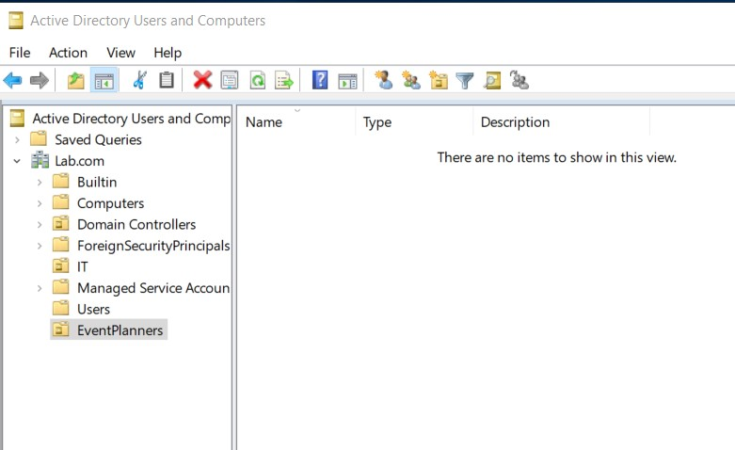
- Add three user accounts to the 'EventPlanners' OU with usernames inspired by your favorite IPL cricket players (e.g., viratk, msdhoni, hardikp). Set a strong password for each and ensure 'User must change password at next logon' is enabled.
➢
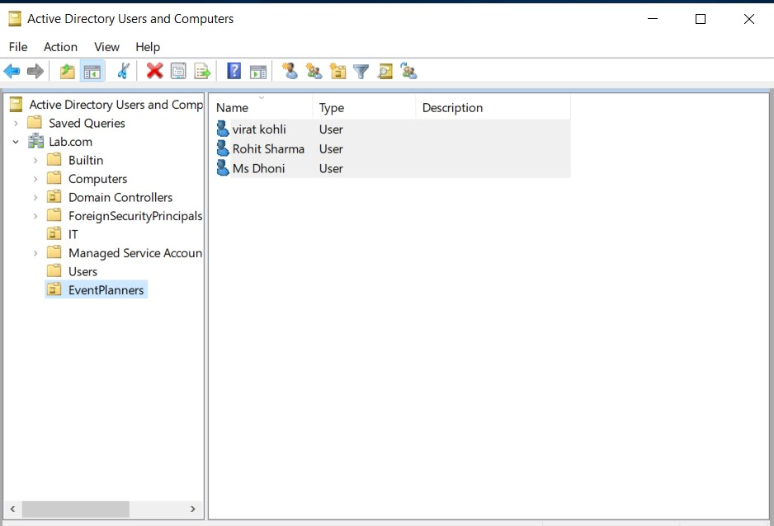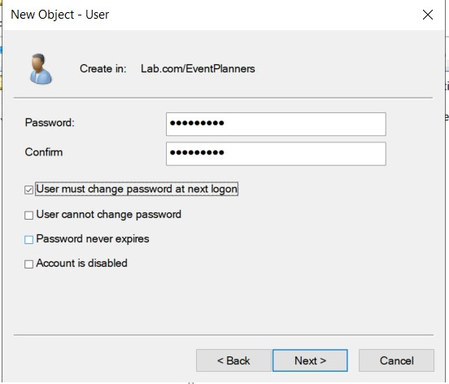
- Create a security group named 'FestTicketManagers' inside the 'EventPlanners' OU. Add all three user accounts you created to this group.
➢
Step 1: Open ADUC
Press Win + R, type dsa.msc, and press Enter.
Step 2: Select the EventPlanners OU
Expand the anant.local domain and locate the EventPlanners OU.
Step 3: Create the Security Group
Right-click EventPlanners, select New → Group, and enter FestTicketManagers as the group name.
Step 4: Configure Group Properties
Select Global as the group scope and Security as the group type. Click OK to create the group.
Step 5: Add the Three Users
Right-click FestTicketManagers and select Properties. Open the Members tab and click Add.
Step 6: Select User Accounts
Enter viratk, msdhoni, and hardikp. Click Check Names and then OK to add the users.
Step 7: Verify Membership
Open the group's Properties and check the Members tab to confirm that all three accounts are listed.
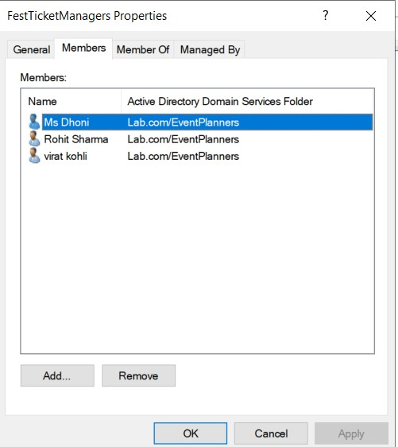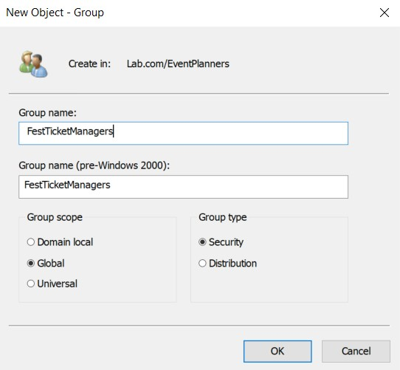

4. Rename one of your user accounts in the 'EventPlanners' OU to match your own first name and update their description field to 'Social Media Manager for College Fest'.
➢
